**EEE-1212:Digital Logic Design Lab**

1st Year 2nd Semester

Session: 2015-2016

**Experiment Number:** 10

**Name of the Experiment:**

Design and construction of a 4 to 2 bit encoder

**Submitted by:**

**Group:** 3

Nusrat Munia

Roll: SK-03

Palash Roy

Roll: JH-24

Abdullahil Baki Arif

Roll: SH-36

**Prepared by:**

Palash Roy

Roll: JH-24

**Experiment Date**: 6th November 2016

**Submission Date**: 22th November 2016

**Submitted to:**

1. Dr.Suraiya Pervin, Professor, Dept. of CSE, DU

2. Ms. Iffat Anjum, Lecturer, Dept. of CSE, DU

**Experiment Name:**

Design and construction of a 4 to 2 bit encoder

**Objectives:**

The objectives of this lab is to understand the internal circuity of 4 to 2 bit encoder and implement 4 to 2 bit encoder circuit and testing the encoder circuit by comparing with truth table.

**Theory:**

The opposite of this decoding process is called encoding and is performed by a logic circuit called an encoder. An encoder has a number of input lines, only one of which is activated at a given time, and produces an *N*-bit output code, depending on which input is activated. If a encoder has 2N input lines then we can say it has N output lines.

We saw that a binary-to-octal decoder (3-line-to-8-line decoder) accepts a

three-bit input code and activates one of eight output lines corresponding to

that code. An octal-to-binary encoder (8-line-to-3-line encoder) performs the opposite function: it accepts eight input lines and produces a three-bit output

code corresponding to the activated input. Similarly a 4 line to 2 line decoder accepts four bit input code and produces a two-bit output code corresponding to the activated input.

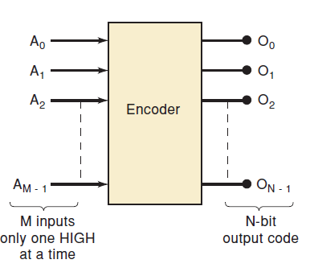

Fig: General Encoder Diagram

**Instruments:**

1. A trainer board
2. 3 IC(s) IC-7486, IC-7408 ,IC- 7400
3. Connecting wires

**Procedure:**

1. At first we placed the integrated circuit with IC-7408 ,IC-7486 and IC-7400 on a breadboard properly. This IC(s) are placed across the gap in the center of the breadboard .
2. Then we connected the inputs to the IC- 7408 logic with the logic sources and its output from IC-7408 to the logic indicator.
3. Gave biasing to the ICs with the VCC(5 volt) and GND(0 volt), and do necessary connections according to the circuit diagram .
4. For various input combinations we observe the output for each one is applied .
5. The output of the circuit will be shown on the LED. (LED Off = 0, LED On = 1).

**Result:**

|  |  |  |  |  |  |
| --- | --- | --- | --- | --- | --- |
| Input | | | | Output | |
| I3 | I2 | I1 | I0 | O1 | O0 |
| 0 | 0 | 0 | 1 | 0 | 0 |
| 0 | 0 | 1 | 0 | 0 | 1 |
| 0 | 1 | 0 | 0 | 1 | 0 |
| 1 | 0 | 0 | 0 | 1 | 1 |

O1 = +

=

= 

O0 = +

=

= 

**Discussion:**

In this experiment we have to implement 4 line to 2 line encoders . But we faced some problems when we do this experiment.

1. At first we started work with IC-7400 in place of IC-7486. So we didn’t get proper output for a long time. We didn’t understand what mistakes we have done. Then we check the IC no after a long time started our work perfectly.
2. In this experiment we have to use 3 IC(s) at the same time . So we need too many IC(s) wires to connect the IC(s) among themselves.

But we figured them out and completed our experiment successfully.